VBA based ERP solution for business management

- Main Menu: Display all business departments
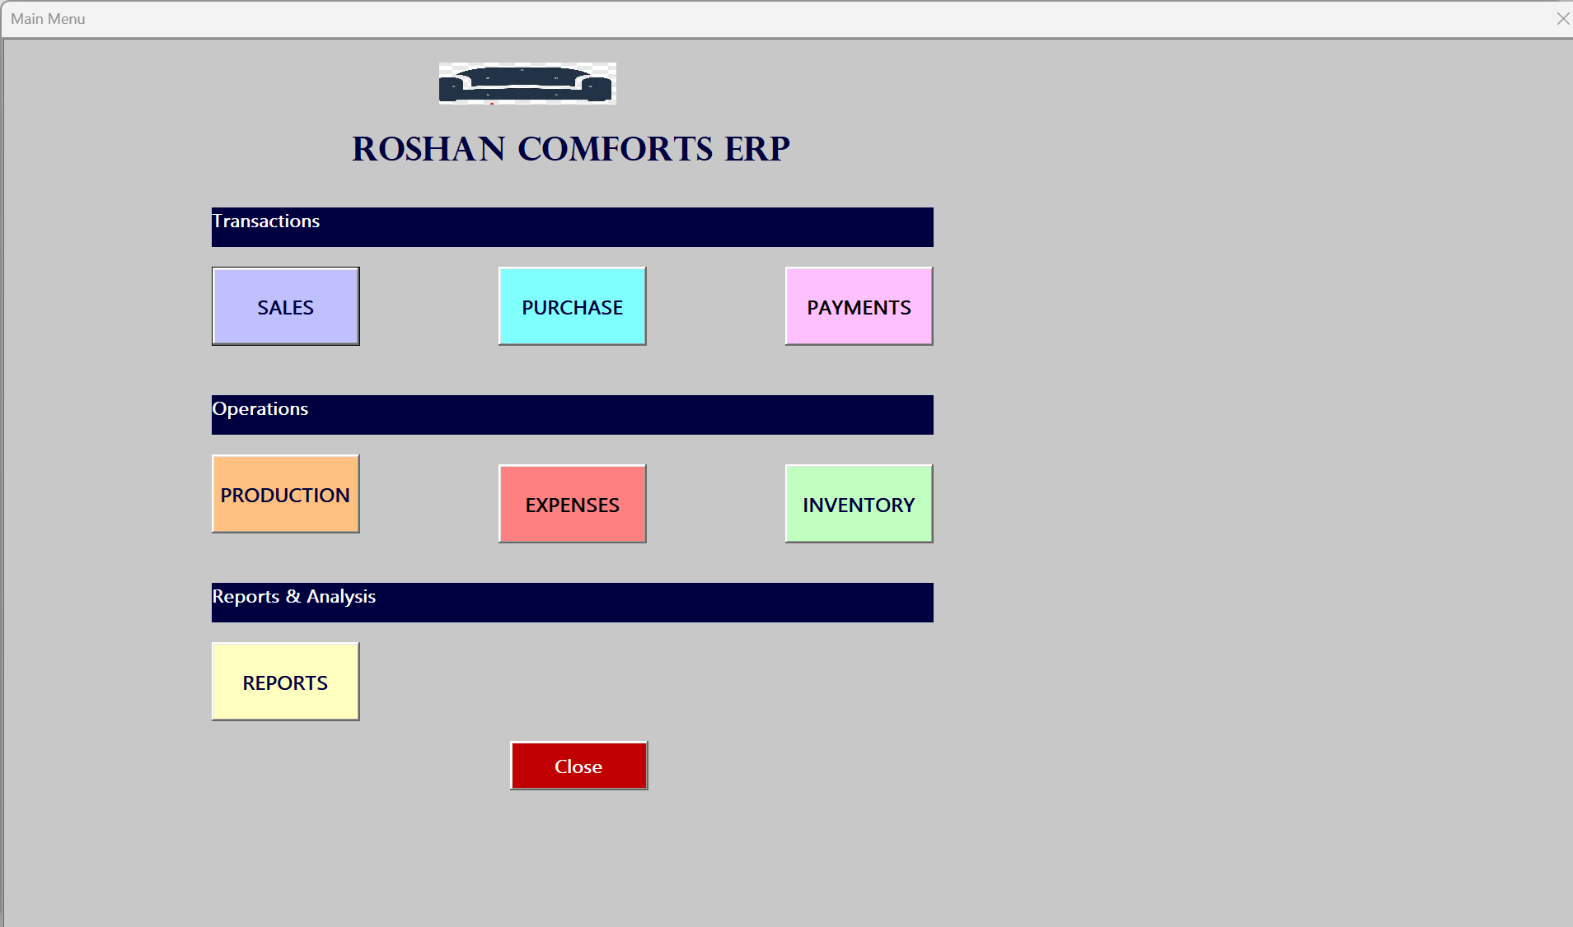
- Sales Module: Responsible for generating the sales data
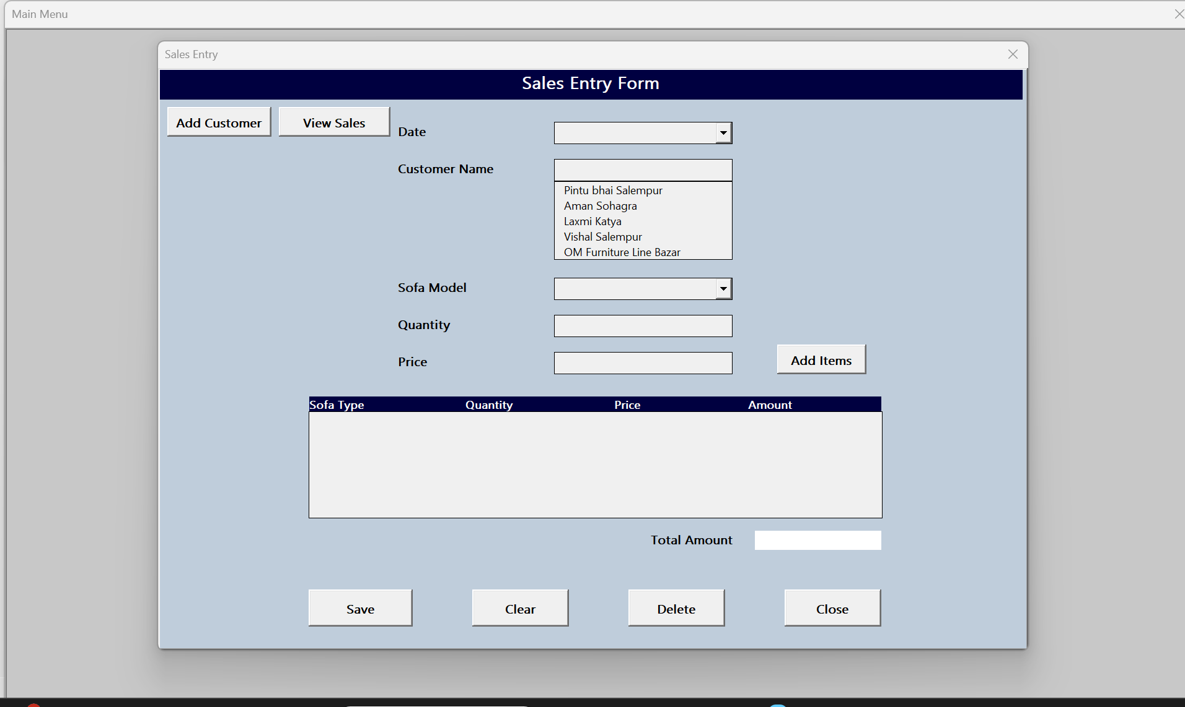
Add new Customer
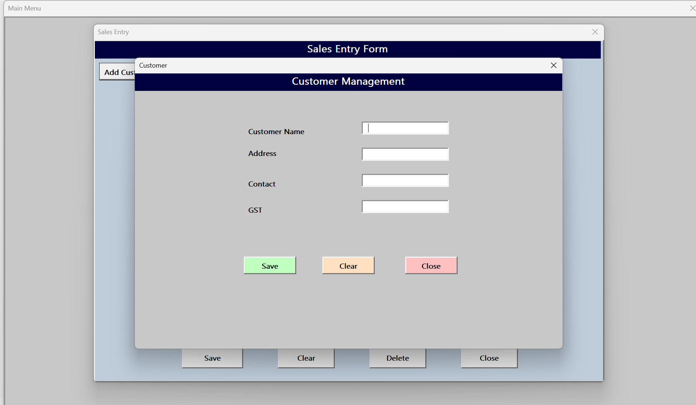
Display all sales until now. User can filter based on date and customer as well
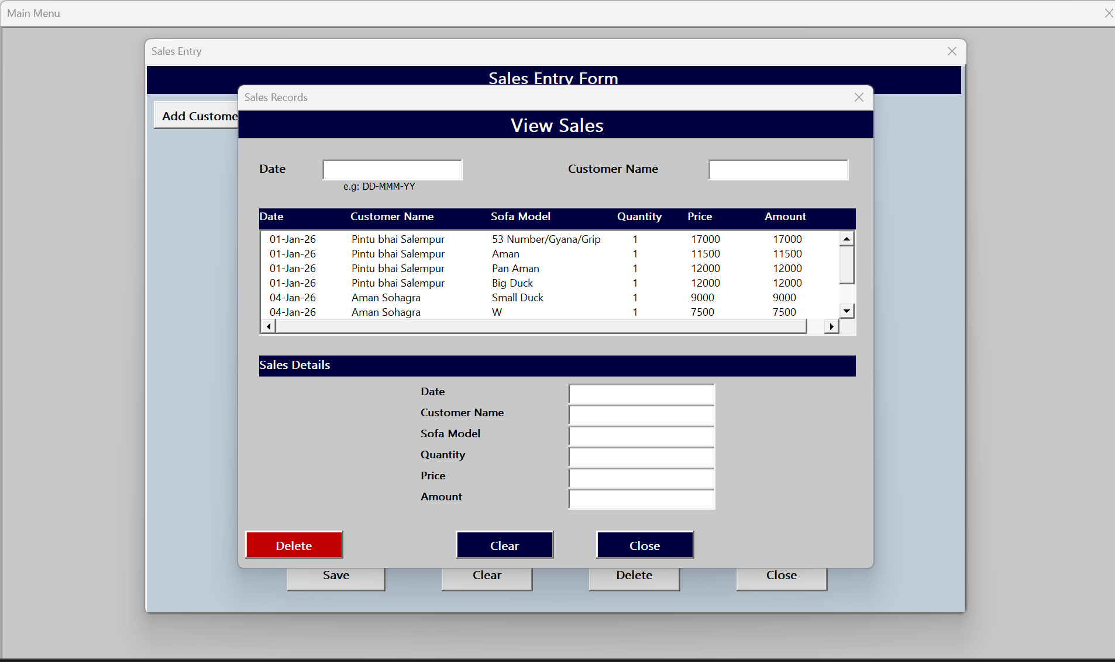
Purchase module: Responsible for enter the all purchases
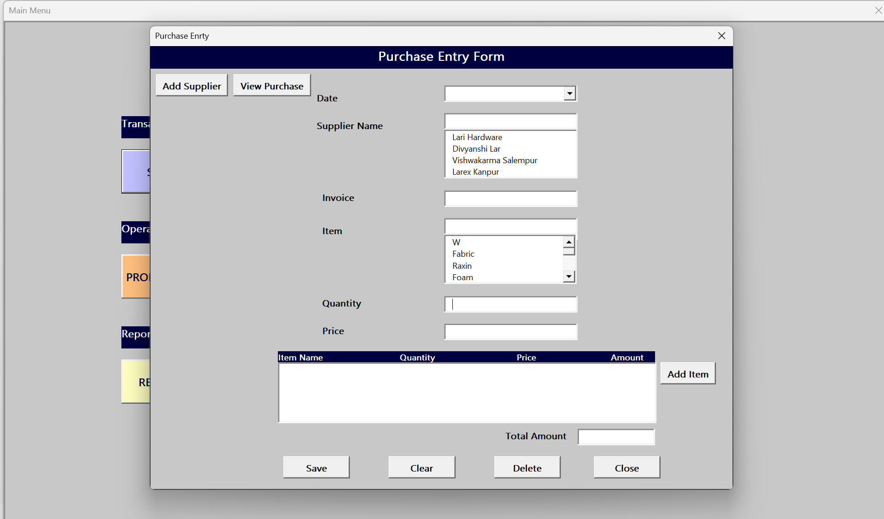
Add supplier (in case new supplier)
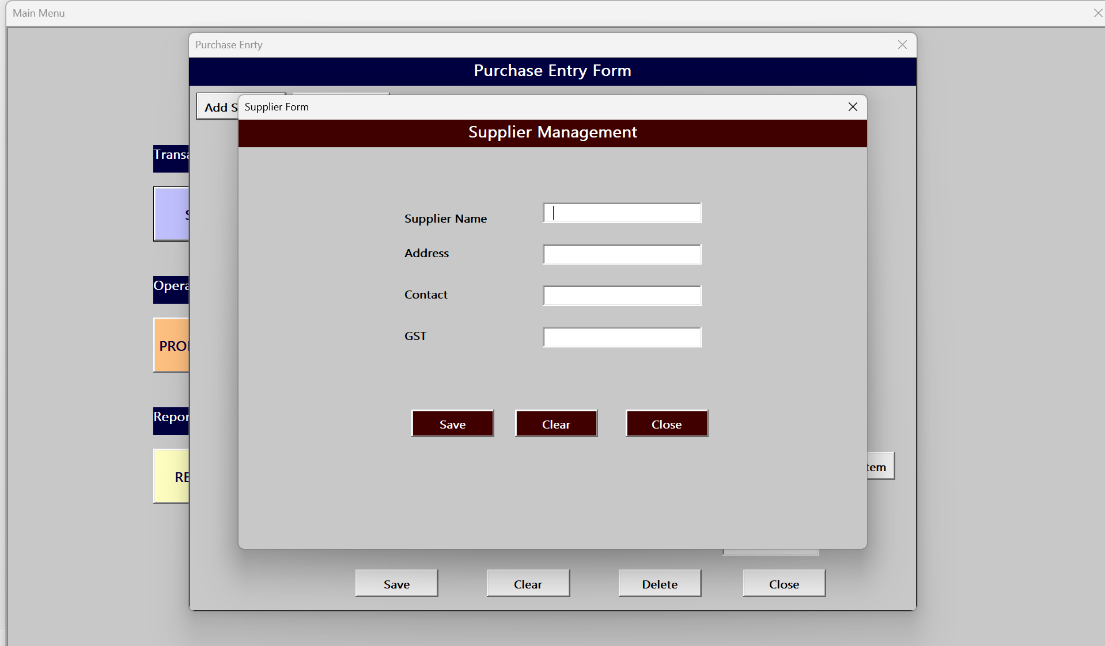
Display al purchase until now and can filter based on date and supplier
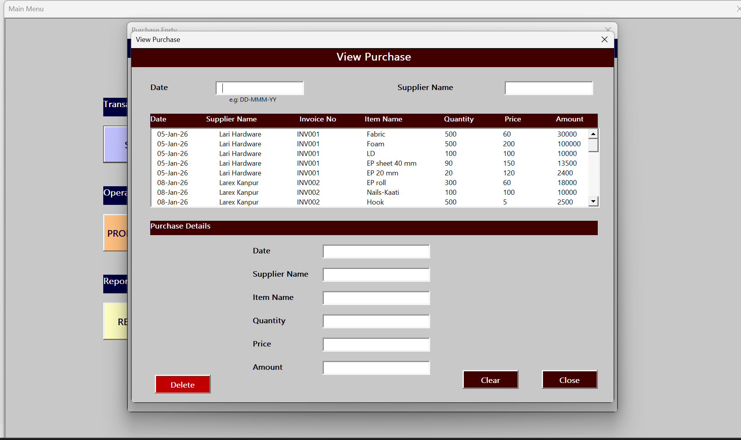
Payment module: records all payment either from customer, supplier or Labour
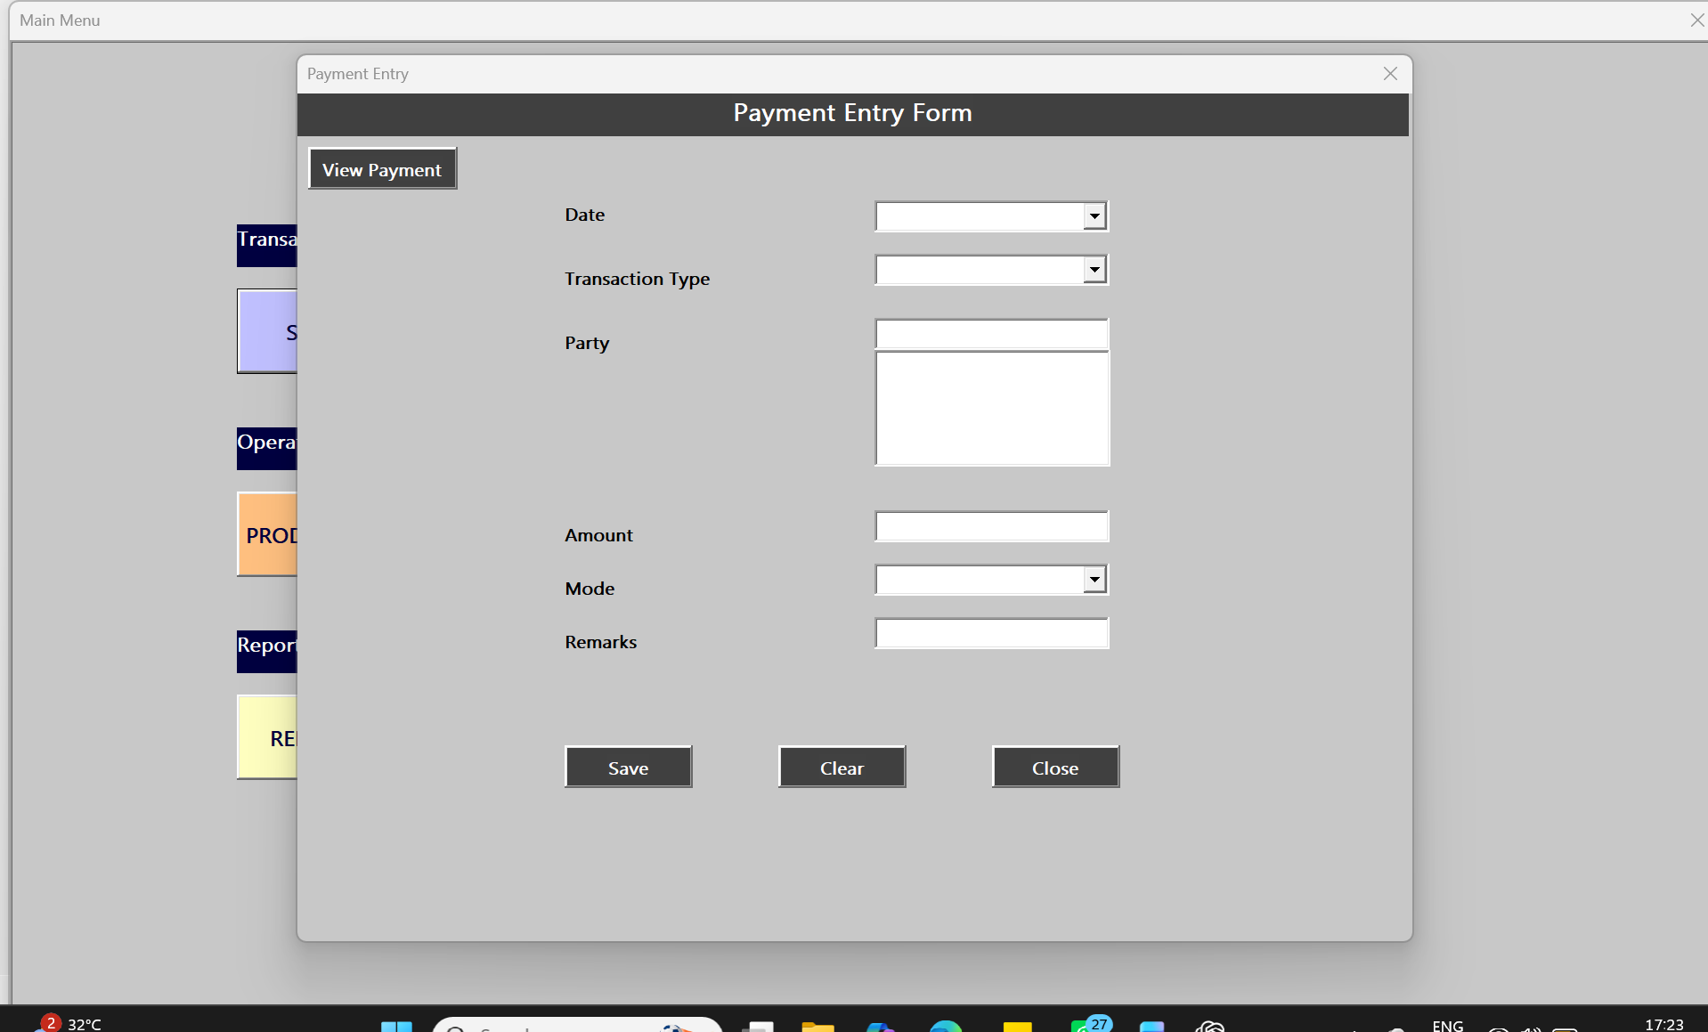
Display all payment made/received until now and can filter based on date and type
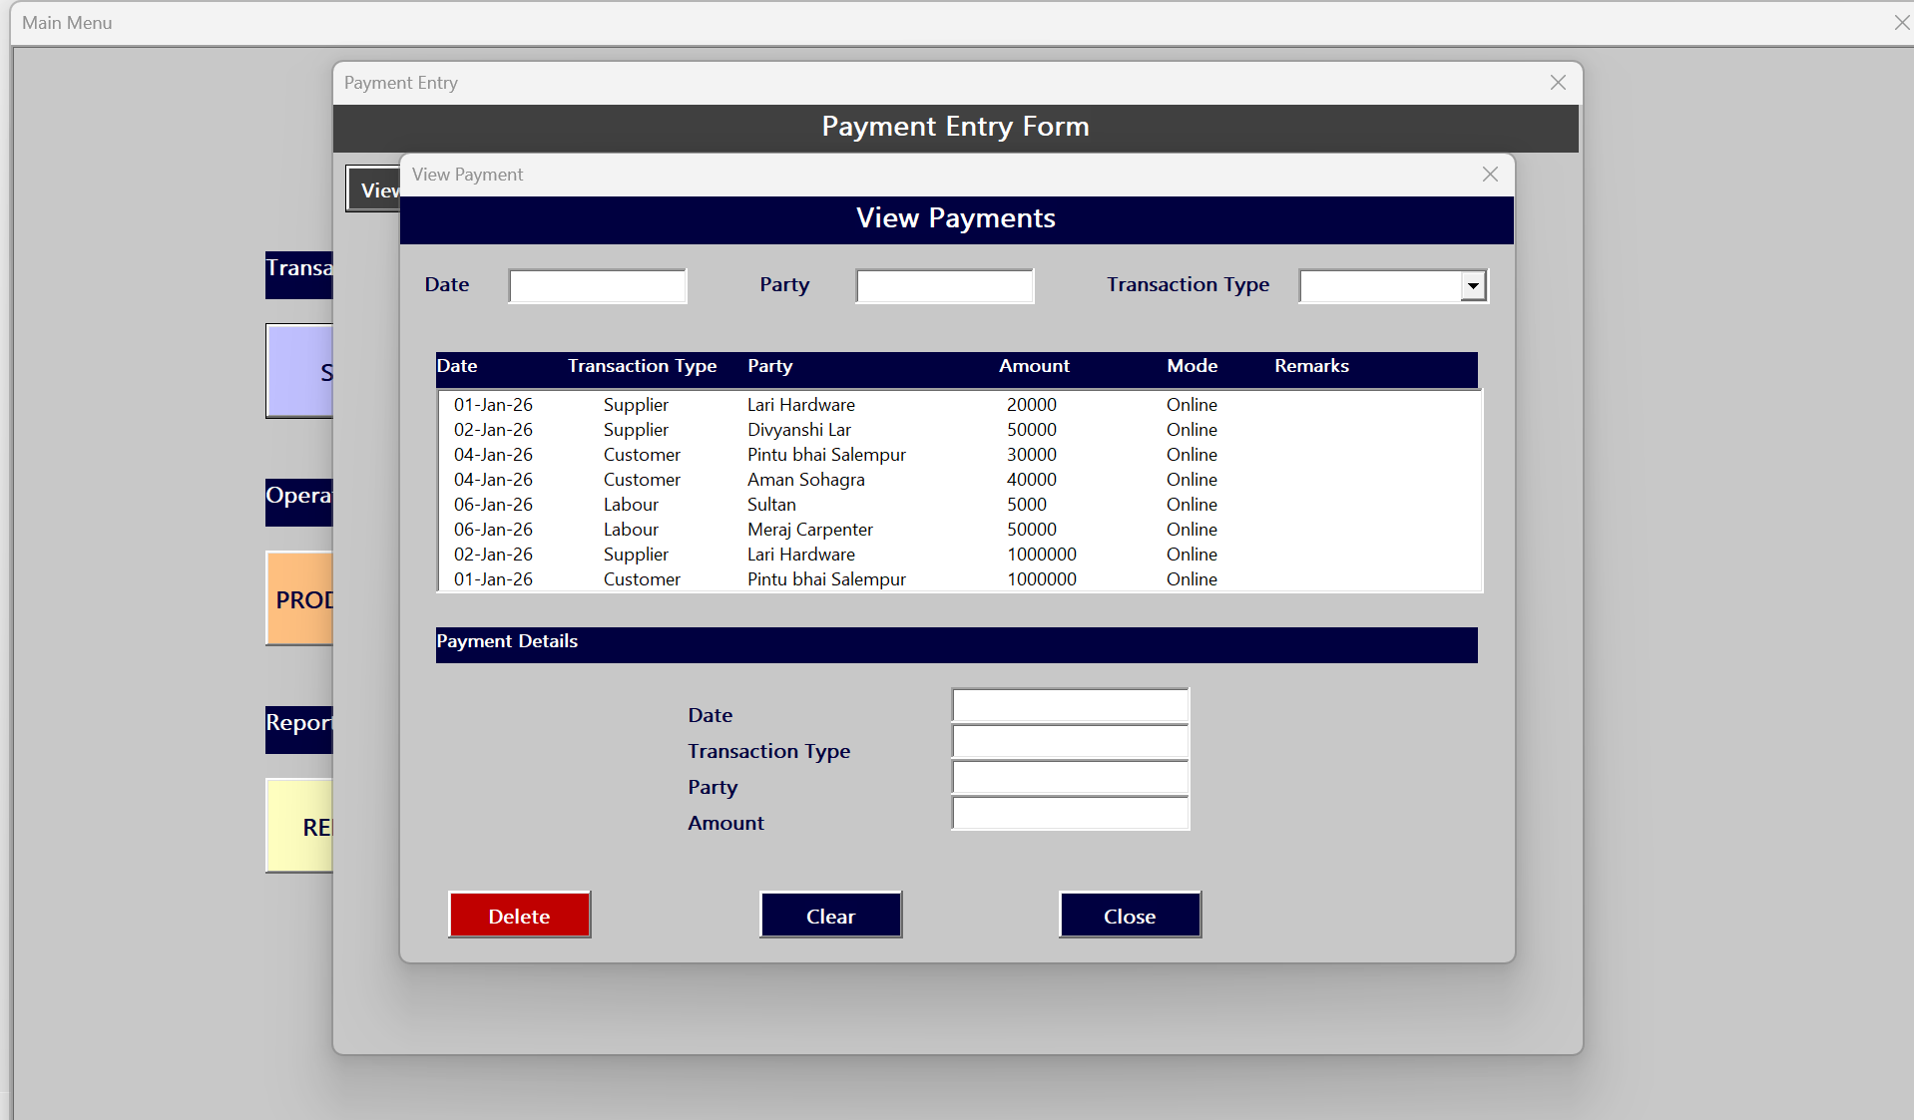
Production module: responsible for recording all production per day and total charges made per labour
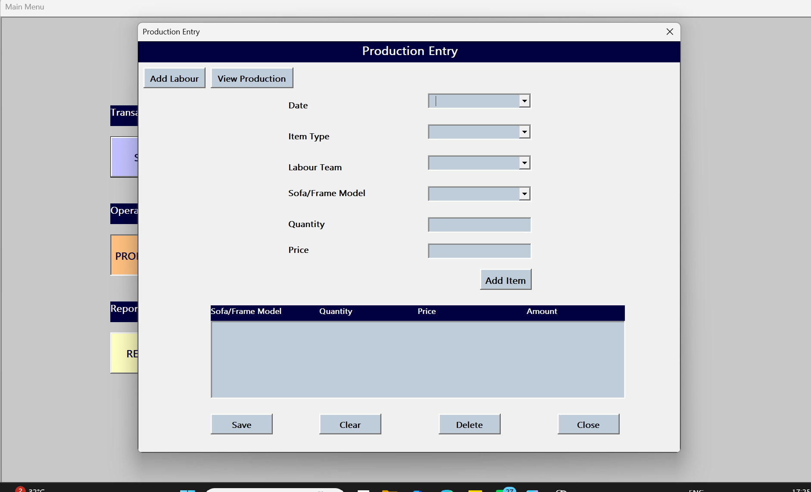
Add a Labour( if new)
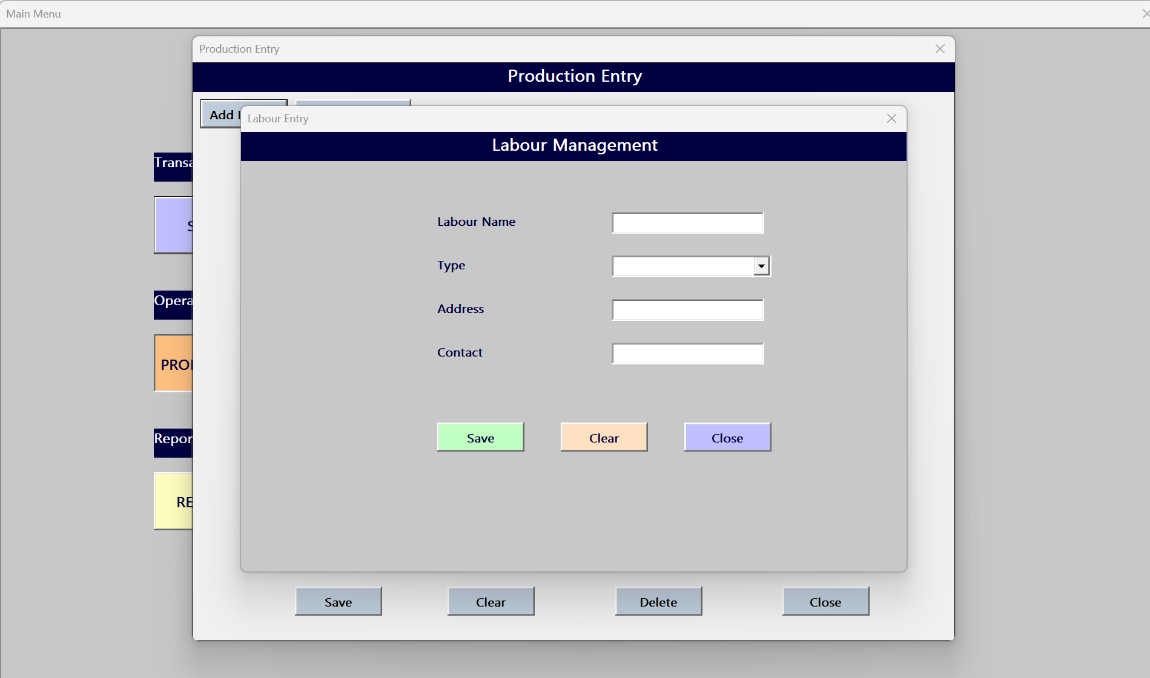
Display all production done until now can filter based on date and sofa labour name
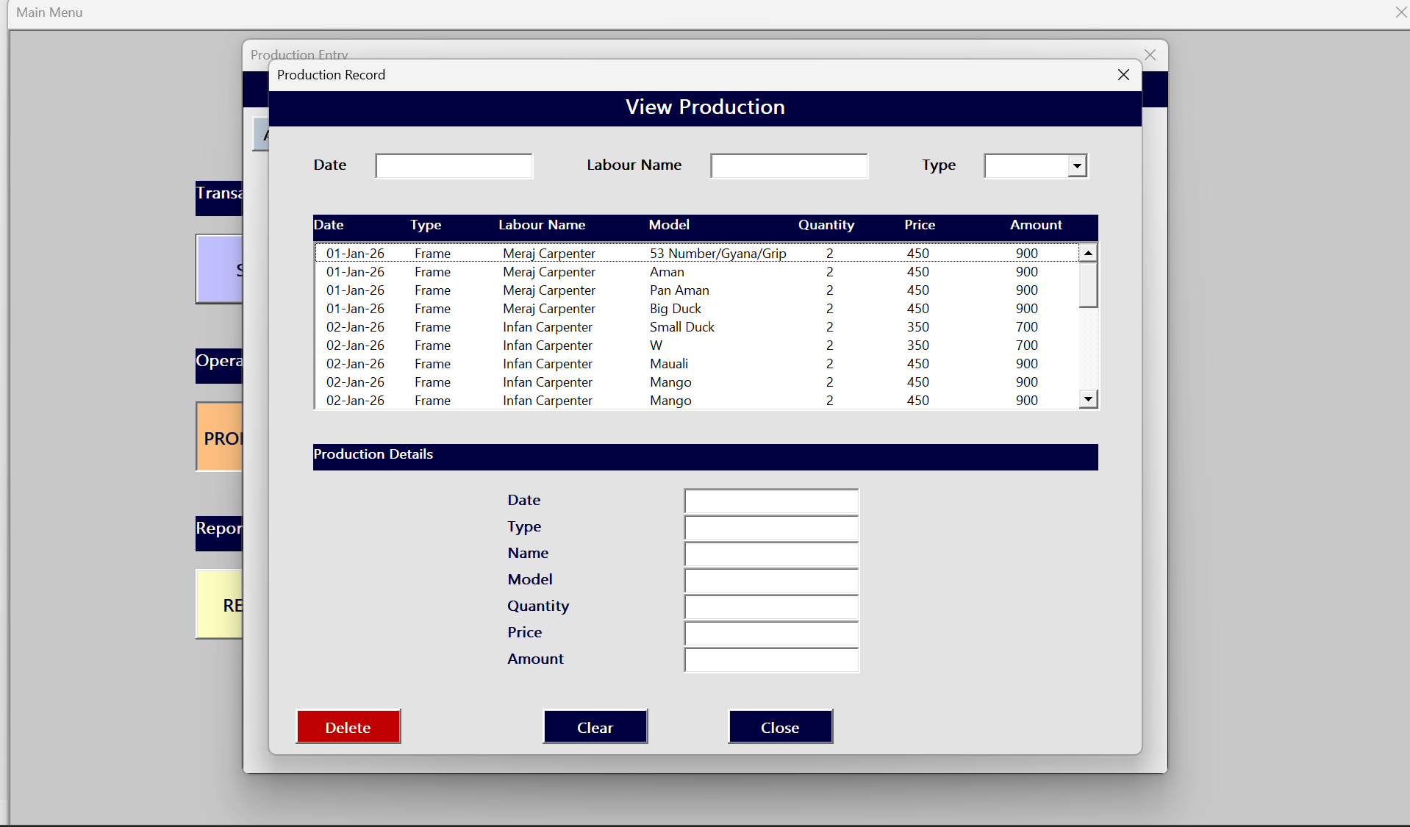
Expense module: responsible for recording all expanse made to run the factory day wise:
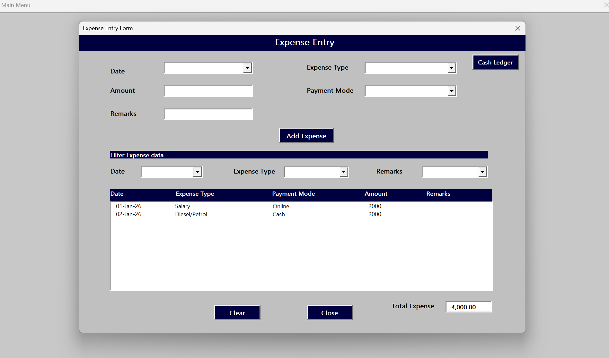
Cash management:
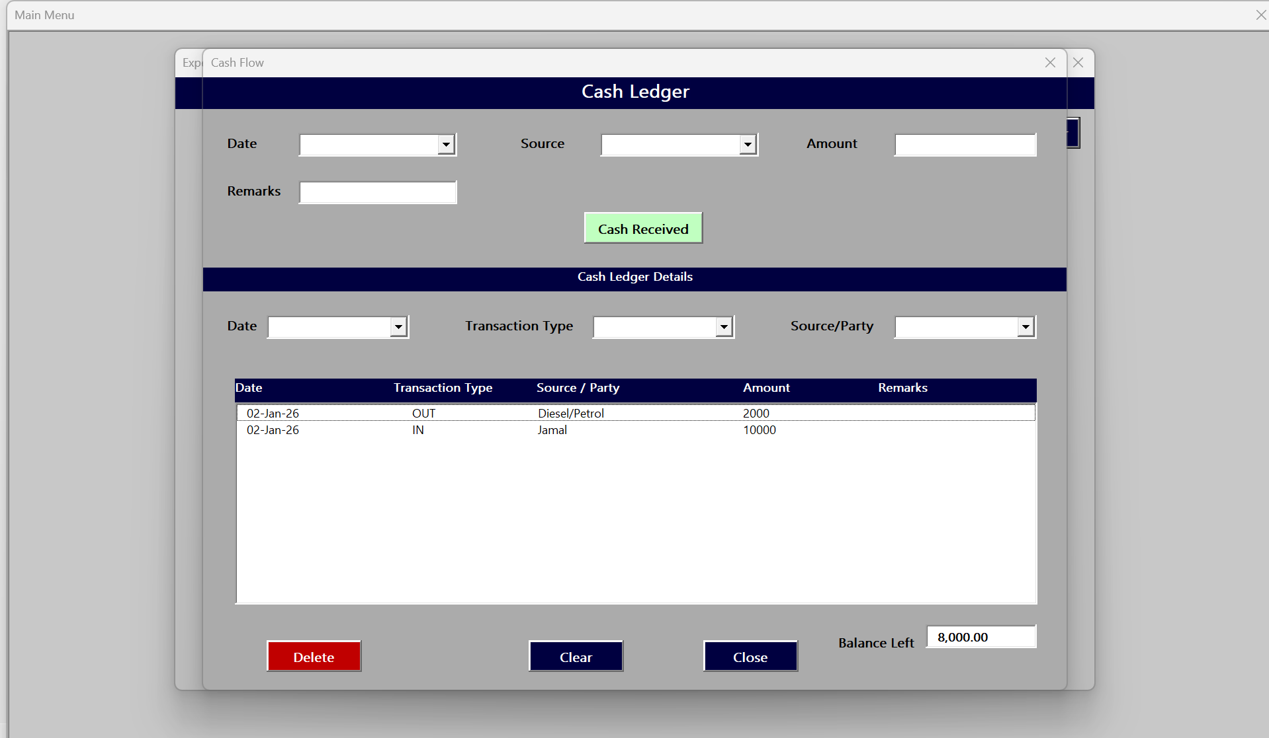
Inventory management and analysis or raw material s well finished product
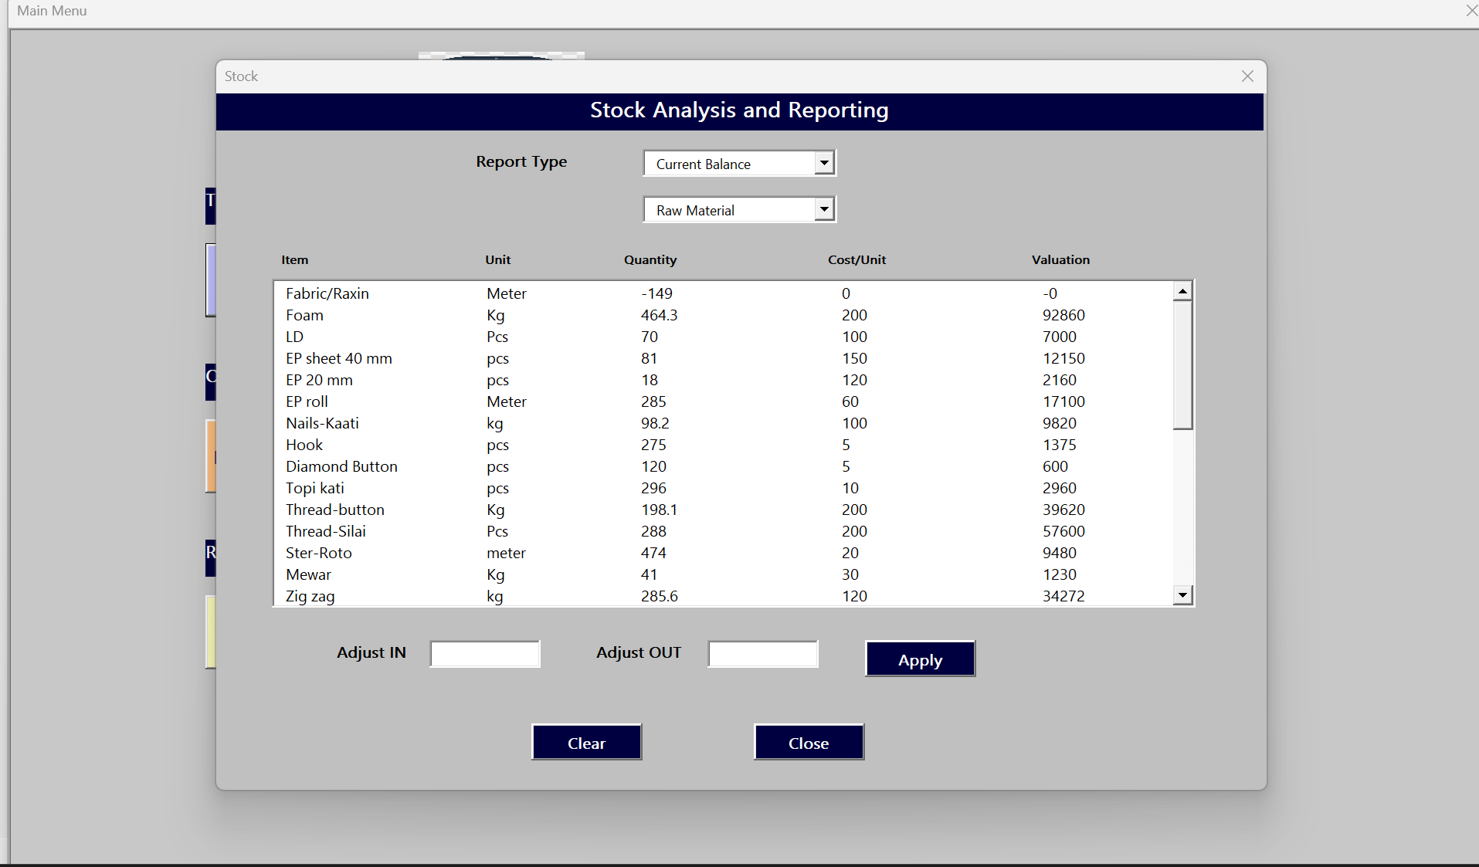
Reporting: Maintains customer, supplier, labours ledger report as well as have following links Sales report, Purchase Report and Production report
